By Calum Oke, Tuan Phan, Timmothy Riggs and Thomas Reidy

Assignment 2 - Mobile App Prototype

report

Contents

User Interface Design: 2

Software Architecture: 2

Testing and Quality Assurance Strategy: 2

Reflection on Learning: 2

# User Interface Design:

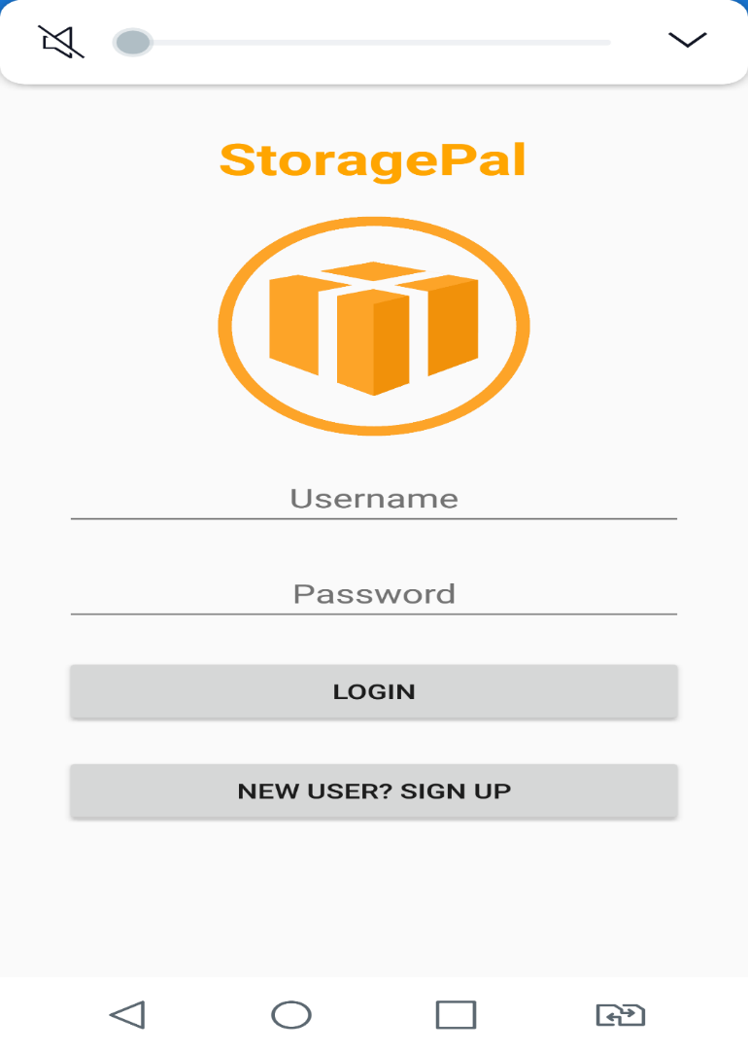

Figure 1: Login page

The login page is the first page of the application. The user must enter a username and password in order to use the functions of the application. The login details are save in the database, which all the passwords are hashed for security reasons. If the user hasn’t register for the username, the user can click on the signup button to register a new account. The signup button will move the user to the registration page of the app. If the user enters a valid combination of username and password, the user will be able to use the app.

Design: Because the login page is the front page of the application, the page should be simple

# Software Architecture:

# Testing and Quality Assurance Strategy:

# Reflection on Learning: